UAT Plan

for

studyMe

Index

1. Scope 3

1.1. Objectives and business requirements 3

1.2. Scope 3

2. Testing team 4

3. Environmental requirements 5

3.1. Hardware requirements 5

3.2. Software requirements 5

4. Test Scripts 1

# Scope

## Objectives and business requirements

We will be testing the UI of the landing page only

## Scope

Testing UI of landing page only

Responsive nature of page

## System Diagrams

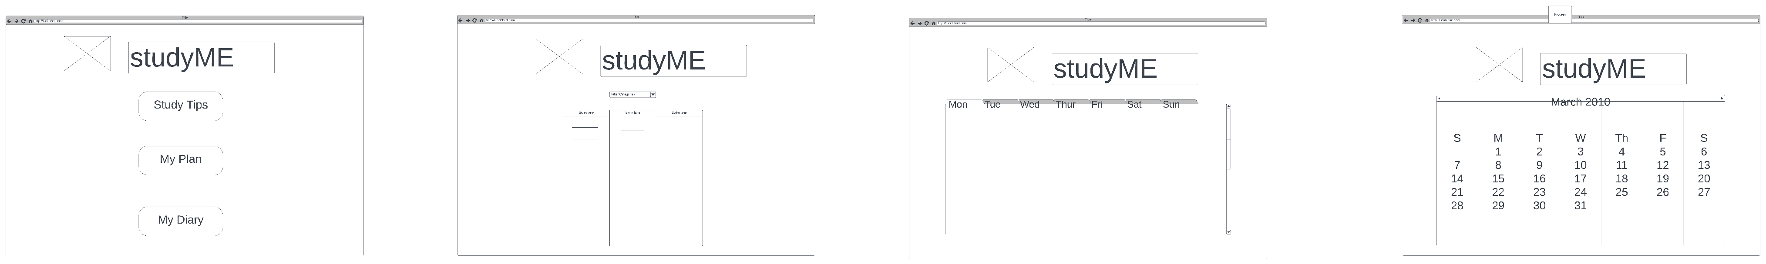

# Testing team

In this section, list out members of your QA team and what their roles will be during UAT.

|  |  |
| --- | --- |
| **Name** | **Responsibilities** |
| Charlie Fitz | UAT Testing |
|  |  |
|  |  |
|  |  |
|  |  |

# Environmental requirements

## Hardware requirements

Apple iPhone 7 or newer

Windows PC

## Software requirements

Safari Browser (iPhone)

Chrome (PC)

## Network requirements

WWW connectivity

# Test Scripts

This section is more important than it seems—it is crucial that both the QA team and the testers know what features must be tested, especially if you’re testing a lot at once.

|  |  |  |  |  |
| --- | --- | --- | --- | --- |
| **Test** | **Describe the feature being tested** | **Describe the user input or test data** | **Describe the pass criteria** |  |
| 1 | Page loads on desktop | 1. Navigate to <https://tempehs.github.io/2024SDD-Ben-studyME/> on a windows PC | Page should load like this: | Tester name:   |  |  | | --- | --- | |  | PASS | |  | FAIL |   Observations: |
| 2 | Page is mobile responsive | Navigate to <https://tempehs.github.io/2024SDD-Ben-studyME/> iPhone |  | Tester name:   |  |  | | --- | --- | |  | PASS | |  | FAIL |   Observations: |

Tip: Write step-by-step, detailed but concise instructions on how to test the feature.